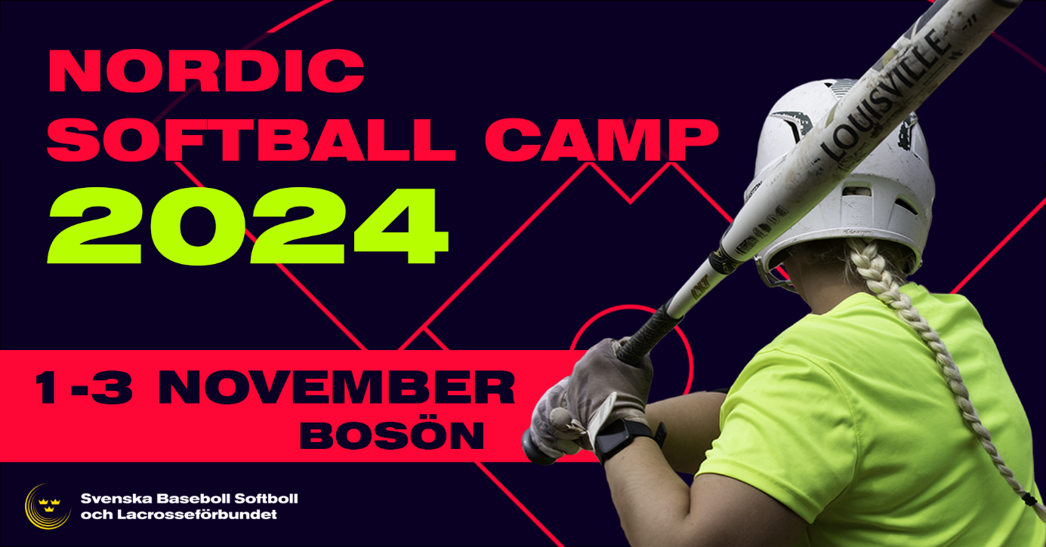

Invitation Nordic Softball Camp 2024
We are happy to once again invite players and coaches to a training camp that will be out of the ordinary!
For three days you will have the chance to learn from some of Europe's best coaches on site at our beautiful training facility Bosön, nearby Stockholm!
The camp is aimed at both players and coaches and is open to participants from Sweden, Norway, Denmark and Finland. We plan to offer all participants a customized focus. Therefore, participants will also be divided based on experience to provide the best possible experience. The camp will be led by well-qualified international coaches with arrangements like previous years.
We meet at Bosön on Friday morning November 1st and continue until lunchtime on Sunday November 3rd.
Food and accommodation during the camp is included in the price. Accommodation is optional and participation fee will be reduced if accommodation is not chosen.
The accommodation offers part of a four-bed room, and the food is served on site at Bosön’s excellent facility. Breakfast, lunch, dinner and coffee are included during the camp. Please note: Breakfast on Friday and lunch on Sunday are not included.
If you want to arrive early, say on Thursday, we suggest that you contact Bosön yourself and book accommodation between Thursday and Friday.
For practical questions, please contact Monica Söderberg at our Federations office; monica.soderberg@sbslf.se.

Target group
- Female players aged 14 and up who want to develop their game.
- Coaches who want to develop their coaching skills.

Time: 10:00 a.m. Friday Nov. 1 until lunch on Sunday Nov. 3
Location: Bosön, Stockholm. Link: Träning, utbildning och konferens på Lidingö | Boson.se

Price for Nordic participants (without membership in SBSLF)
Friday – Sunday: SEK 2 000
Friday – Sunday (without accommodation): SEK 1 500
The participant fee will be invoiced upon receipt of completed registration.

Please note: The camp has a limitation on number of participants and will use the principle first come, first served.
Registration preferably before September 5th via the following link: Registration Nordic Softball Camp 2024
(Registration will be open for a bit longer, but due to booking regulations, the number of places will be further limited after Sept 5, therefore we ask that you please register as soon as possible to be sure to secure your spot.
Please note: Registration is binding after September 5th with no money back guarantee. SBSLF will however support in trying to find a solution.

Warm welcome wishes from the Swedish Baseball, Softball & Lacrosse Federation!

